SETTING UP THE EVENT – Admin part

1. Login to Brazen BCC <https://app.brazenconnect.com/cc/#!login> using your email + password. If you haven’t set up the password, use the forgot password option. You may be asked to complete the multi-factor authentication, just follow the instructions to complete the steps.
2. Once logged in, select “NEW EVENT” option.   
   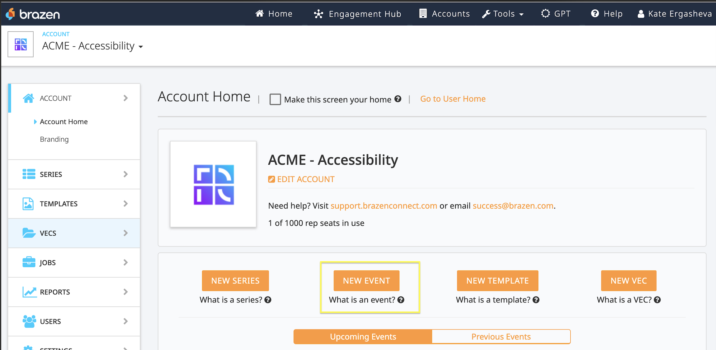
3. Creating the event
   1. For the Template field, select SAMPE OPEN HOUSE EVENT   
      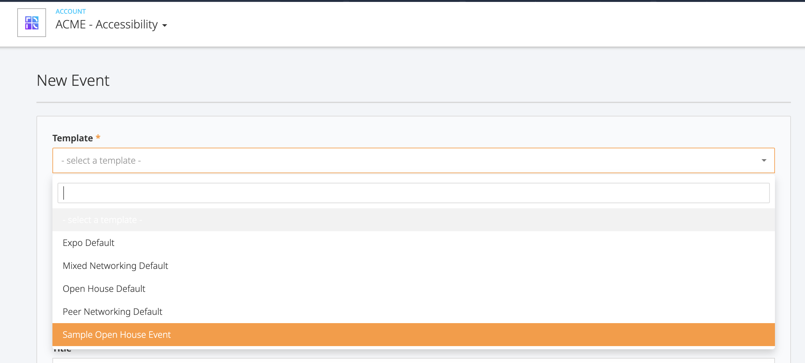
   2. Event Purpose– select Test
   3. Title – ANY (suggestion to use the date in the even title for better tracking)
   4. Fill out other required fields
   5. Make sure to check in the following checkboxes.   
      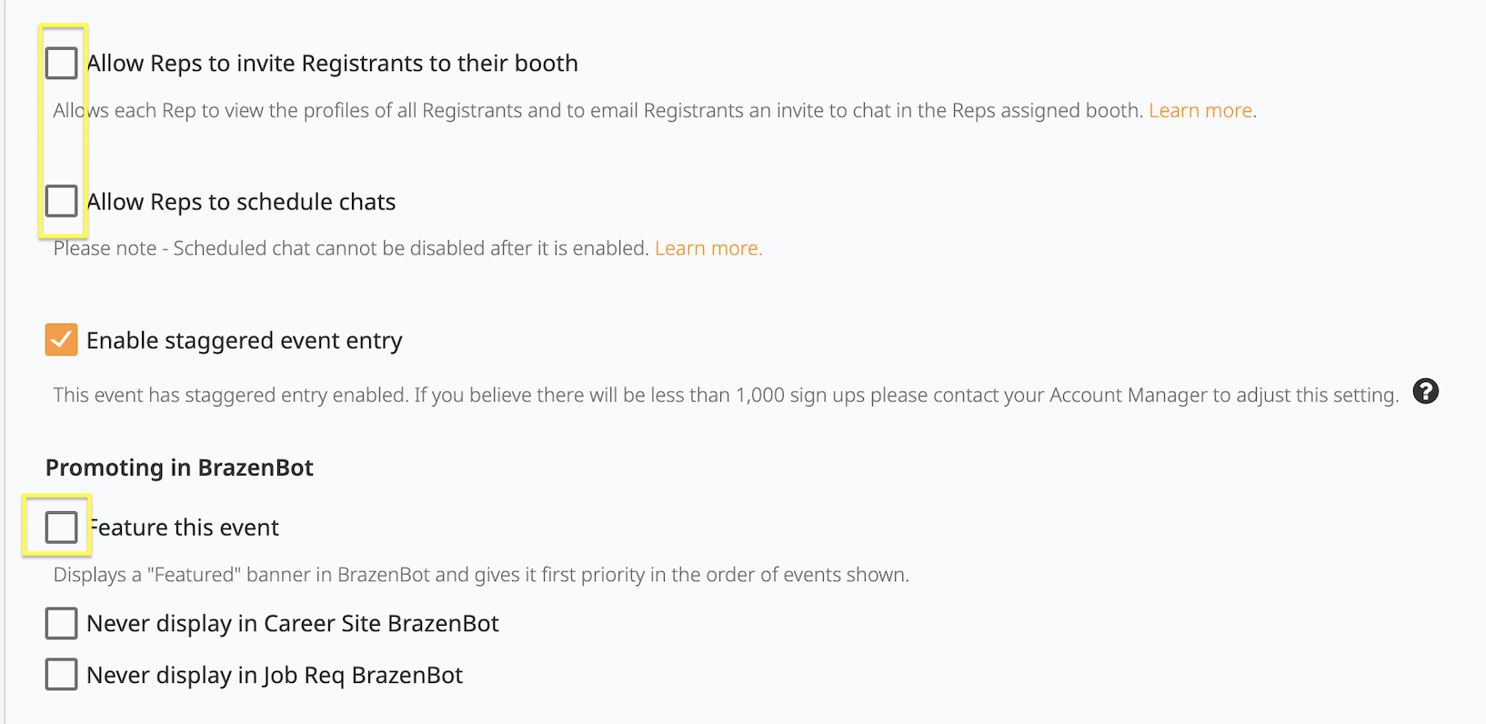

## RETRIEVE THE EVENT URL

1. On the Event Home page, scroll down to copy the live event URL. Copy the URL to open in the new Incognito window. It will open the event landng page with options to register or log in to the event.   
   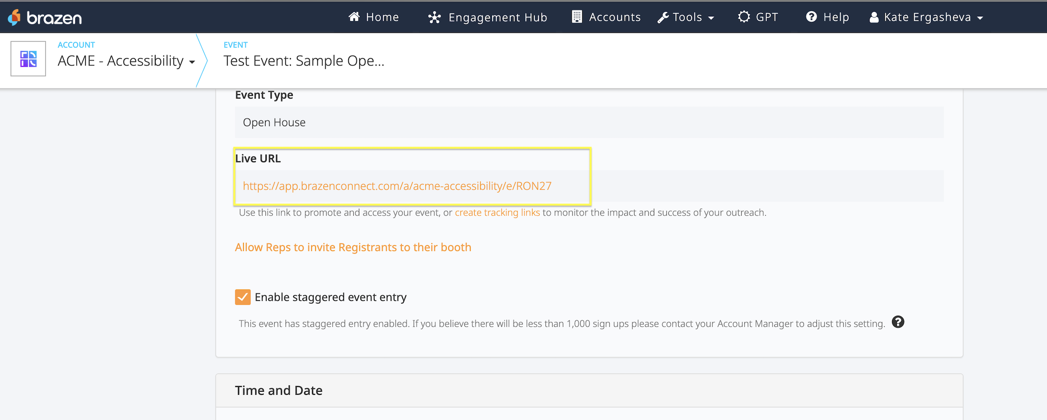
2. Use [email+[anything]@radancy.com](mailto:email+[anything]@radancy.com) to register and login users. Personal recommendations would be to use [email+[date][user.number]@radancy.com](mailto:email+[date][user.number]@radancy.com) For instance [kate.ergasheva+02.06.24one@radancy.com](mailto:kate.ergasheva+02.06.24one@radancy.com)